**Joystick for Commodore – Top Level Project Rev. 0**

**Module description**

Table of Content

Introduction 1

Components 2

Wiring the Joystick 4

Decals 12

Simple interconnect PCB 12

Test 12

# Introduction

This joystick is based on the ZIPPYY arcade joystick, 30mm arcade buttons, a prefabricated joystick cable, a PCB, some wires and a 3D printed enclosure.

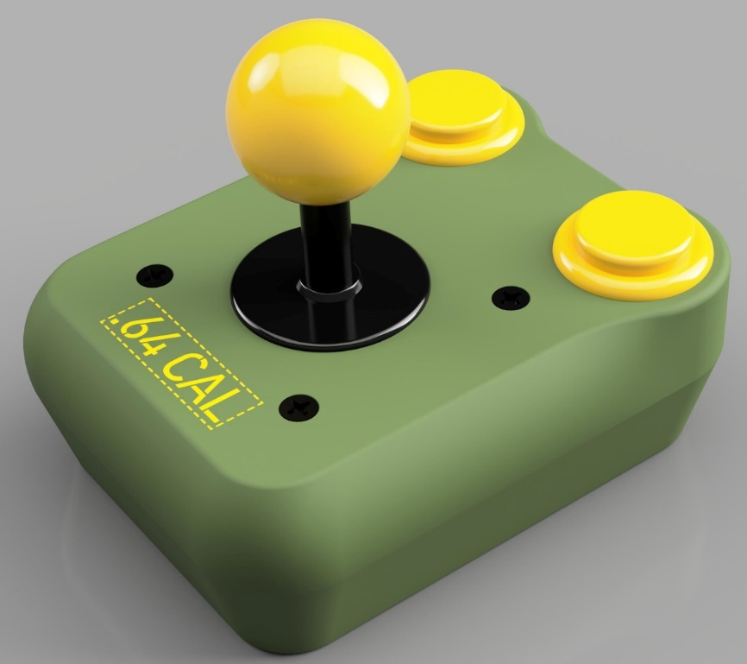

Figure 1: Rendering of the Joystick (Fusion 360)

The ZIPPYY joystick was chosen for the microswitch mechanism with the levers, which seems to be an excellent concept. Other joysticks are a bit less expensive, but since the assembly work for a joystick and the printing time for the enclosure is the crucial factor, the increased material costs for a better quality might make sense.

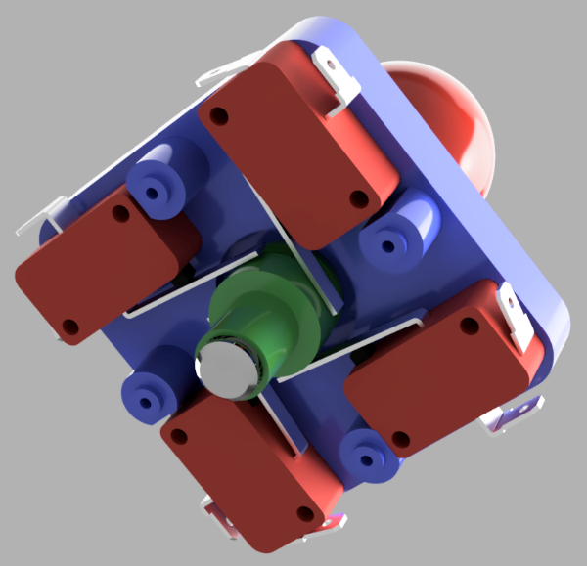

Figure 2: Microswitch mechanism of the ZIPPYY joystick (Fusion 360 rendering).

The interconnects of joysticks, buttons and the cable are accomplished with a PCB. This provides easier assembly and service and reduces the likelihood of failure. It makes the bottom half with the cable and the top half with the joystick and buttons separable.

# Components

The ZIPPYY **joystick** can be found on Ebay and AliExpress. The search terms are “ZIPPYY” or “ZIPPY” and the price varies a lot.

The Arcade buttons are 30mm arcade buttons and can be found on the same sales platforms.

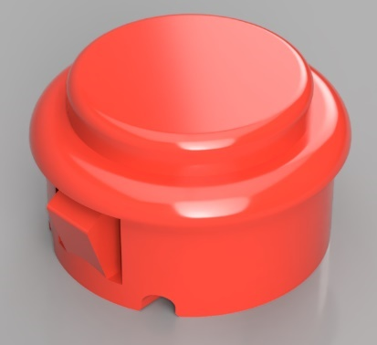

Figure 3: 30mm arcade button (Fusion 360 rendering)

There are different types of 30mm **arcade buttons**, the type shown in Figure 3 fits into the case. Do not use the “long type with screw mounts”. The enclosure fits perfectly with most types. Some have a little bit shorter snap-in pin. Those buttons stay in the enclosure, but might require a drop of hot glue to stay flush.

The prefabricated **cable** is a “5.9ft 1.8M Controller Joystick Extension Cable for Sega Game Console Systems“. The male 9 ways D-SUB connector of this extension cable is not required for the project (It is big, too) and can be cut off. The cable is available from Ebay and AliExpress.

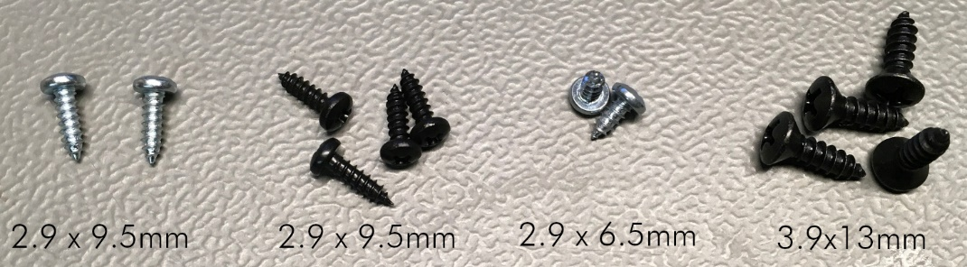

Figure 4: The screws which are used in the assembly

The case consists of three **3D printed parts**: A top shell, a bottom shell and a strain relief. Two or three sorts of **screws** are required:

|  |  |  |  |
| --- | --- | --- | --- |
| Pos. | Qty | Type | Purpose |
| 1 | 2 | 2.9x9.5mm (DIN 7981, tapping screw) | Strain Relief |
| 2 | 4 | 2.9x9.5mm (DIN 7981, tapping screw) | Top to bottom shell |
| 3 | 2 | 2.9x6.5mm (DIN 7981, tapping screw) | PCB to bottom shell |
| 4 | 4 | 3.9x13mm (DIN 7983, tapping screw, countersunk) | Joystick to top shell |

A **simple interconnect PCB** serves for connecting the cable to the ZIPPYY joystick and the arcade buttons.

The countersunk tapping screws are part of the joystick, but it might be desired to have black finished screws. Pos. 1 and 2 are the same type, the screws for the bottom shell might also be wanted with a black finish.

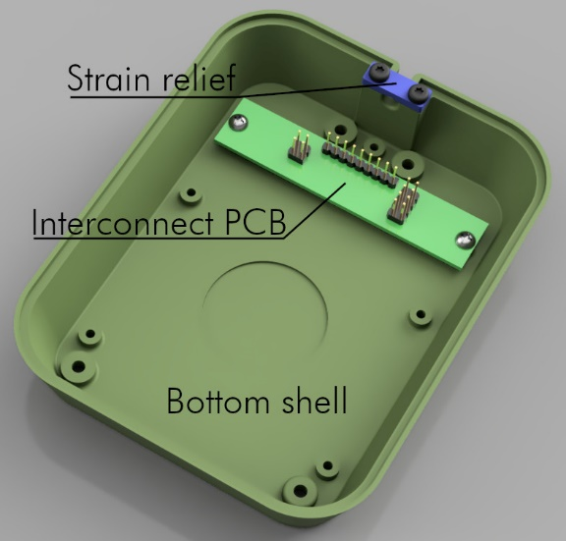

Figure 5: Bottom shell assembly

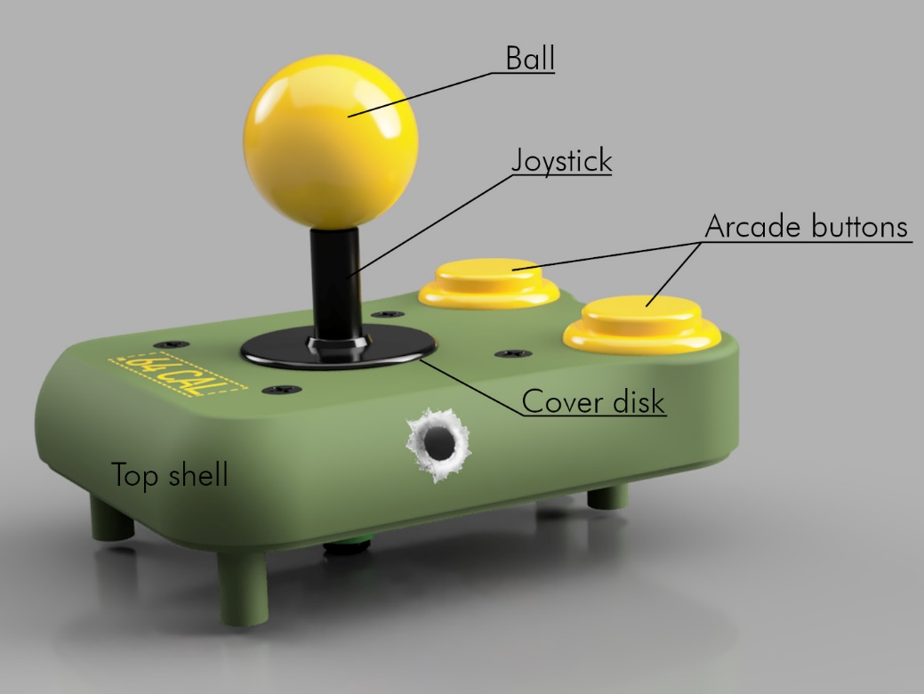

Figure 6: Top shell assembly

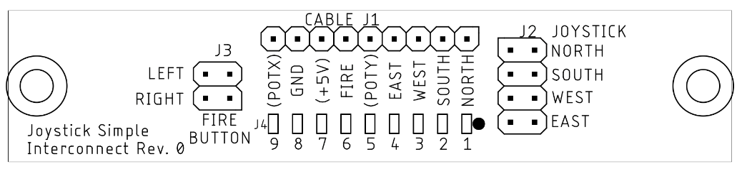

Figure : The PCB (Simple Interconnect)

# Wiring the Joystick

First, the PCB should be mounted in the bottom shell (2.9 x 6.5mm screws). The Male connector should be cut off the joystick cable, then the outer insulation should be stripped off (30mm). The single wires should be stripped off about 2mm, each. Then the cable can be installed with the strain relief. It is recommended to add a cable tie at the end of the outer insulation as an additional slip out protection.

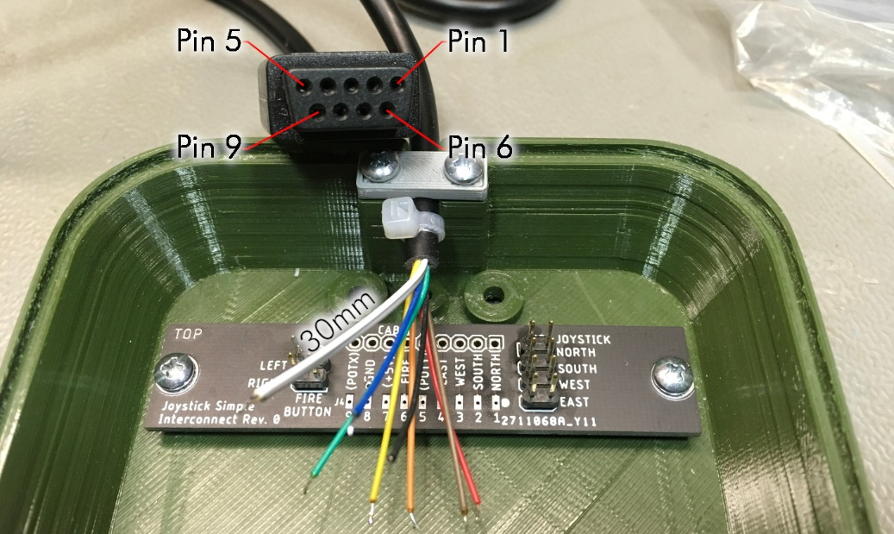

Figure 8: Installing the PCB and the joystick cable

It is not sure, that the wire colors are a standard for all available D-Sub extension cords. So, it is recommended to measure between the pins if the connector and the end of the wires. The numbering of the pins is shown in Figure 8.

The wires are directly soldered to the solder pads (J4) of the installed PCB. This is a comfortable and fast way, that reduces the likelihood of dry solder joints.

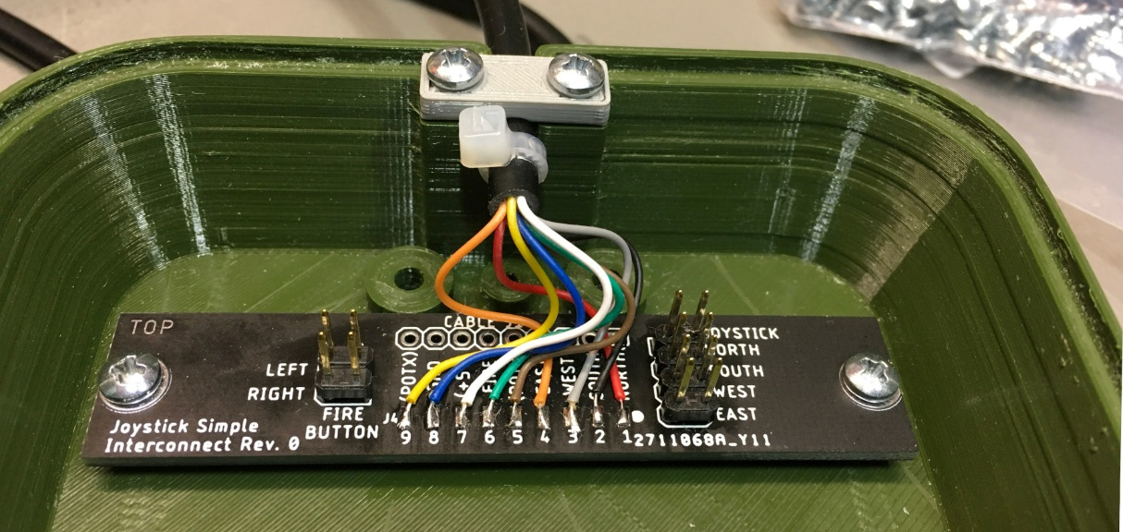

Figure 9: Soldered joystick cable

The colors of the particular joystick cable were colored like this:

| Pad | Color | Function |
| --- | --- | --- |
| 1 | red | North/up |
| 2 | black | South/down |
| 3 | grey | West/left |
| 4 | orange | East/right |
| 5 | brown | PotY |
| 6 | green | Fire |
| 7 | white | +5V |
| 8 | blue | GND |
| 9 | yellow | PotX |

It should always be checked with the ohmmeter, that these colors are correct. Confusing the pins will at least result in an abnormal joystick behavior. In the worst case, the joystick can cause a short circuit between +5V and GND.

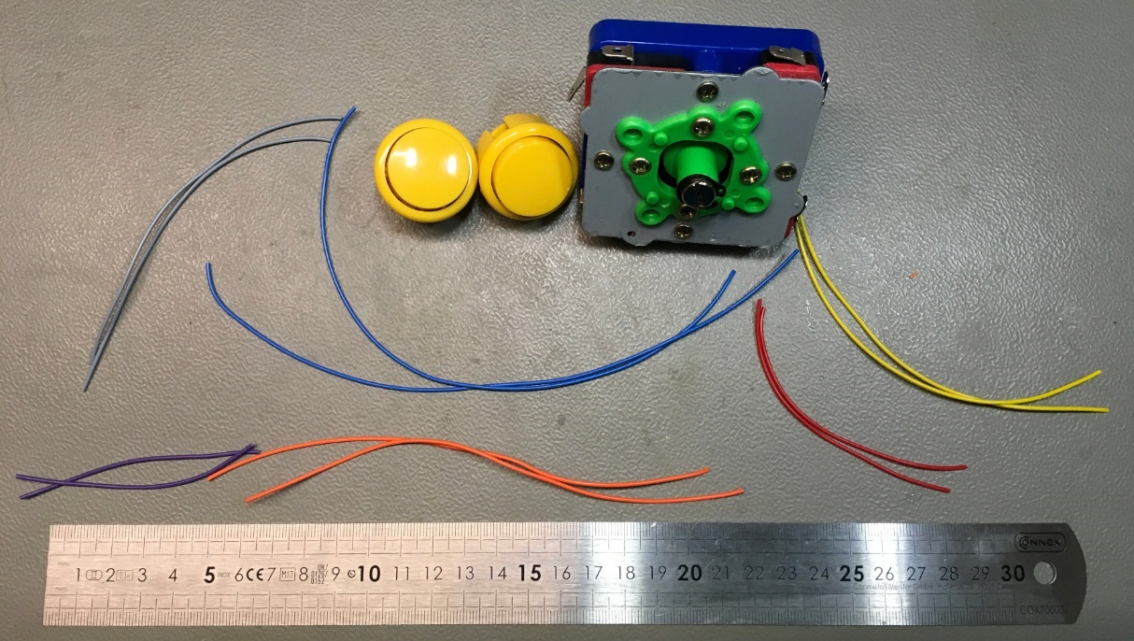

Figure 10: Wiring the joystick and the buttons

It is recommended to wire the joystick with differently colored wires (AWG24/0.25mm²). At least four colors are required top help not confusing the directions. The length can be cut in advance.

|  |  |  |
| --- | --- | --- |
| Direction | Color | Length |
| North | blue | 22cm |
| West | orange | 16cm |
| South | red | 9cm |
| East | yellow | 15cm |
| Right Button | grey | 12cm |
| Left Button | violet | 7cm |

The colors are just a recommendation and depend on the available colors.

It is most comfortable to solder the wires onto the spade connectors of the joystick before it is mounted into the top shell.

For the buttons, shrinkable sleeves can be used (like shown in Figure 11), it is not necessary, though. Here, the directions are also shown.

The top plate of the ZIPPYY joystick is not required and can be removed by screwing off the ball, removing the cover disk and removing the four countersunk screws.

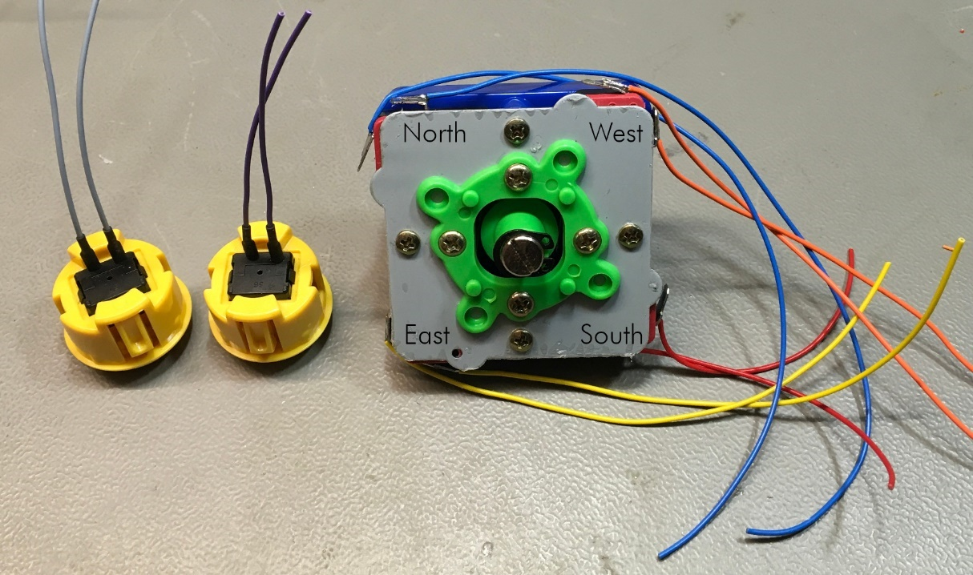

Figure 11: Wires soldered to joystick and buttons

Finally, some cable ties keep the wires in place.

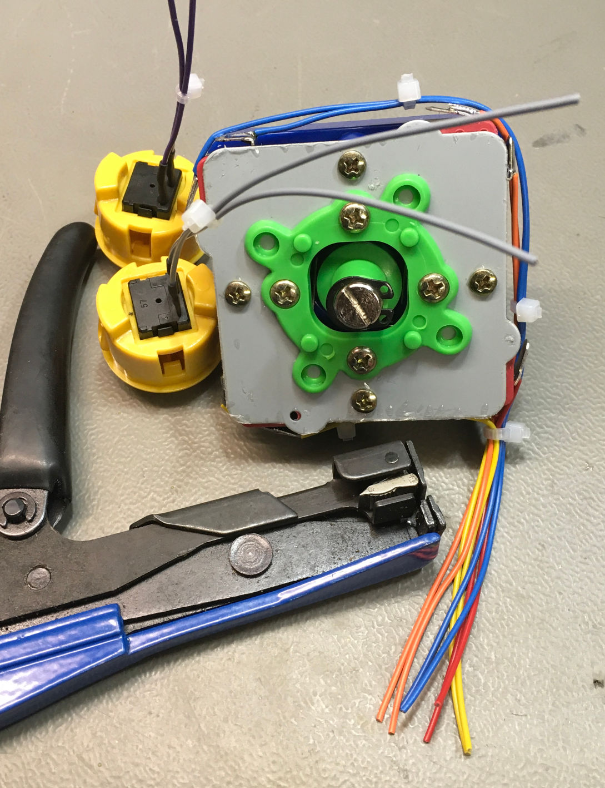

Figure 12: After tying the wires with cable ties, they are cut to length

All wires exit the joystick at the South microswitch (refer to Figure 15). The are a bit unequal and this has to be connected by cutting of the excessive length. The cable bundle should be as long as possible. The shortest wire determines the length of the cable bundle.

Crimping is a good and reliable method to attach connectors to single wires. The DuPont connectors are versatile and wide spread. The crimp tools are inexpensive. Engineer PA-09 or PA-20 are the recommended tools for this purpose.

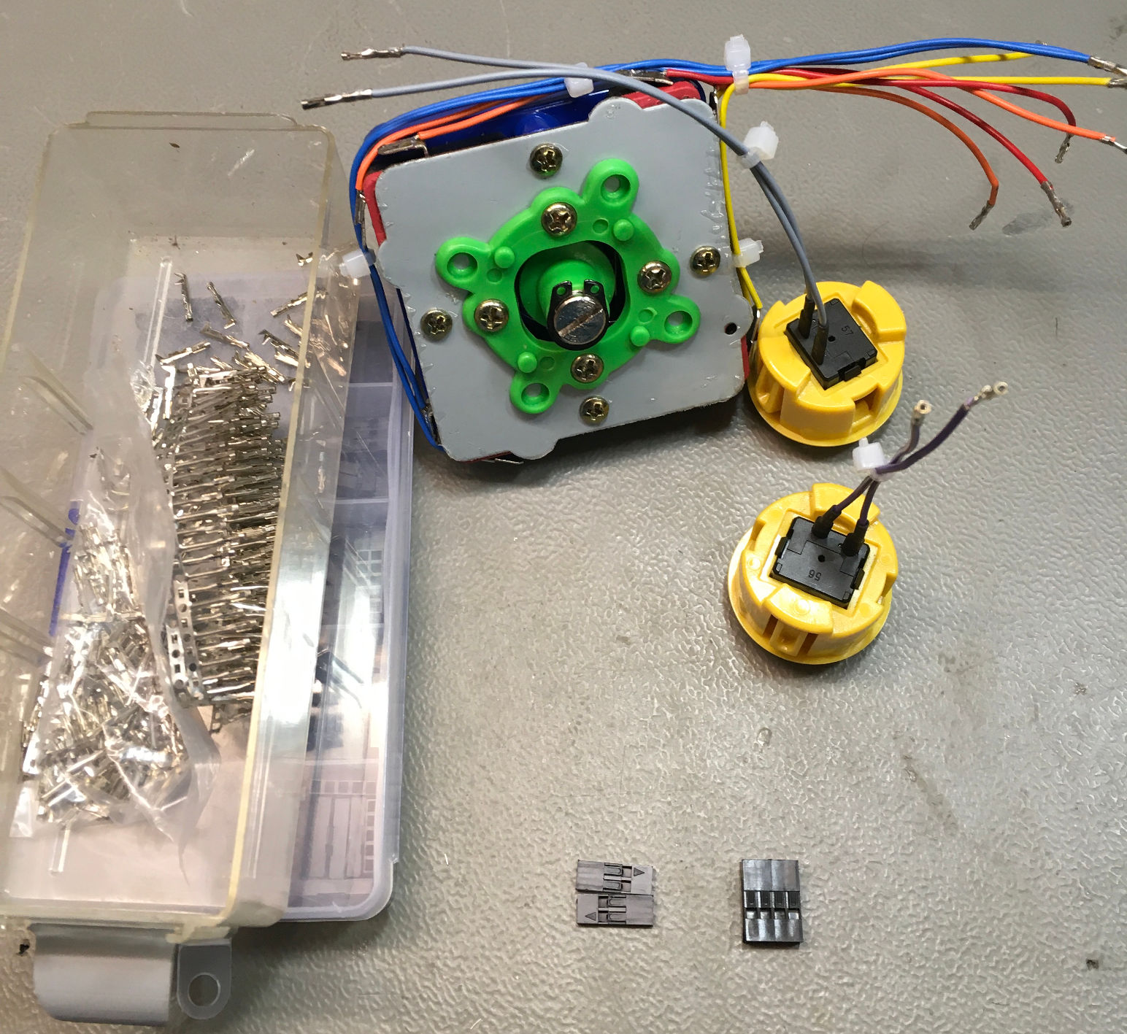

Figure 13: Wires with Dupont crimp terminals

It is not recommended to attach the crimp terminals without suitable tools or to solder the wire stands to the terminals. They will probably not fit into the crimp housing.

In case soldering is preferred over crimping, some socket-strips are a half-decent solution. Another solution would be pre-fabricated DuPont (ribbon) cables (30cm) and the required crimp housings, since the single way crimp housings can be removed easily (slightly lift the holding tongue of the housing) and it is as easy to slide them into the required crimp housing. DuPont cables, terminals and housings are available from the sales platform, mentioned before. In this case, the work has to be done in an inversed sequence. The ribbon cable should stand out about 7-8cm at the “southern” corner of the joystick (Figure 14).then the single wire (pairs) should be separated from the ribbon cable only as far as required and soldered to the spade connectors of the joystick from South, then West, then North, then East on the other side. Cable ties might still be required, but I have not tried out, yet.

Figure 13 shows the joystick and the button wires with crimped Dupont terminals. The crimp housings are also shown here. For the arcade buttons a 1x2 way housing each is suggested, for the joystick a 4x2 housing is required.

It does not matter, which side of the micro switches (of the joystick) is connected to the direction signal and which side to ground.

|  |  |  |  |  |  |
| --- | --- | --- | --- | --- | --- |
| Color | Signal | Pin | Pin | Signal | Color |
| blue | North | 1 | 2 | GND | blue |
| red | South | 3 | 4 | GND | red |
| orange | West | 5 | 6 | GND | orange |
| yellow | East | 7 | 8 | GND | yellow |

The joystick and buttons with crimp housings is shown in Figure 13.

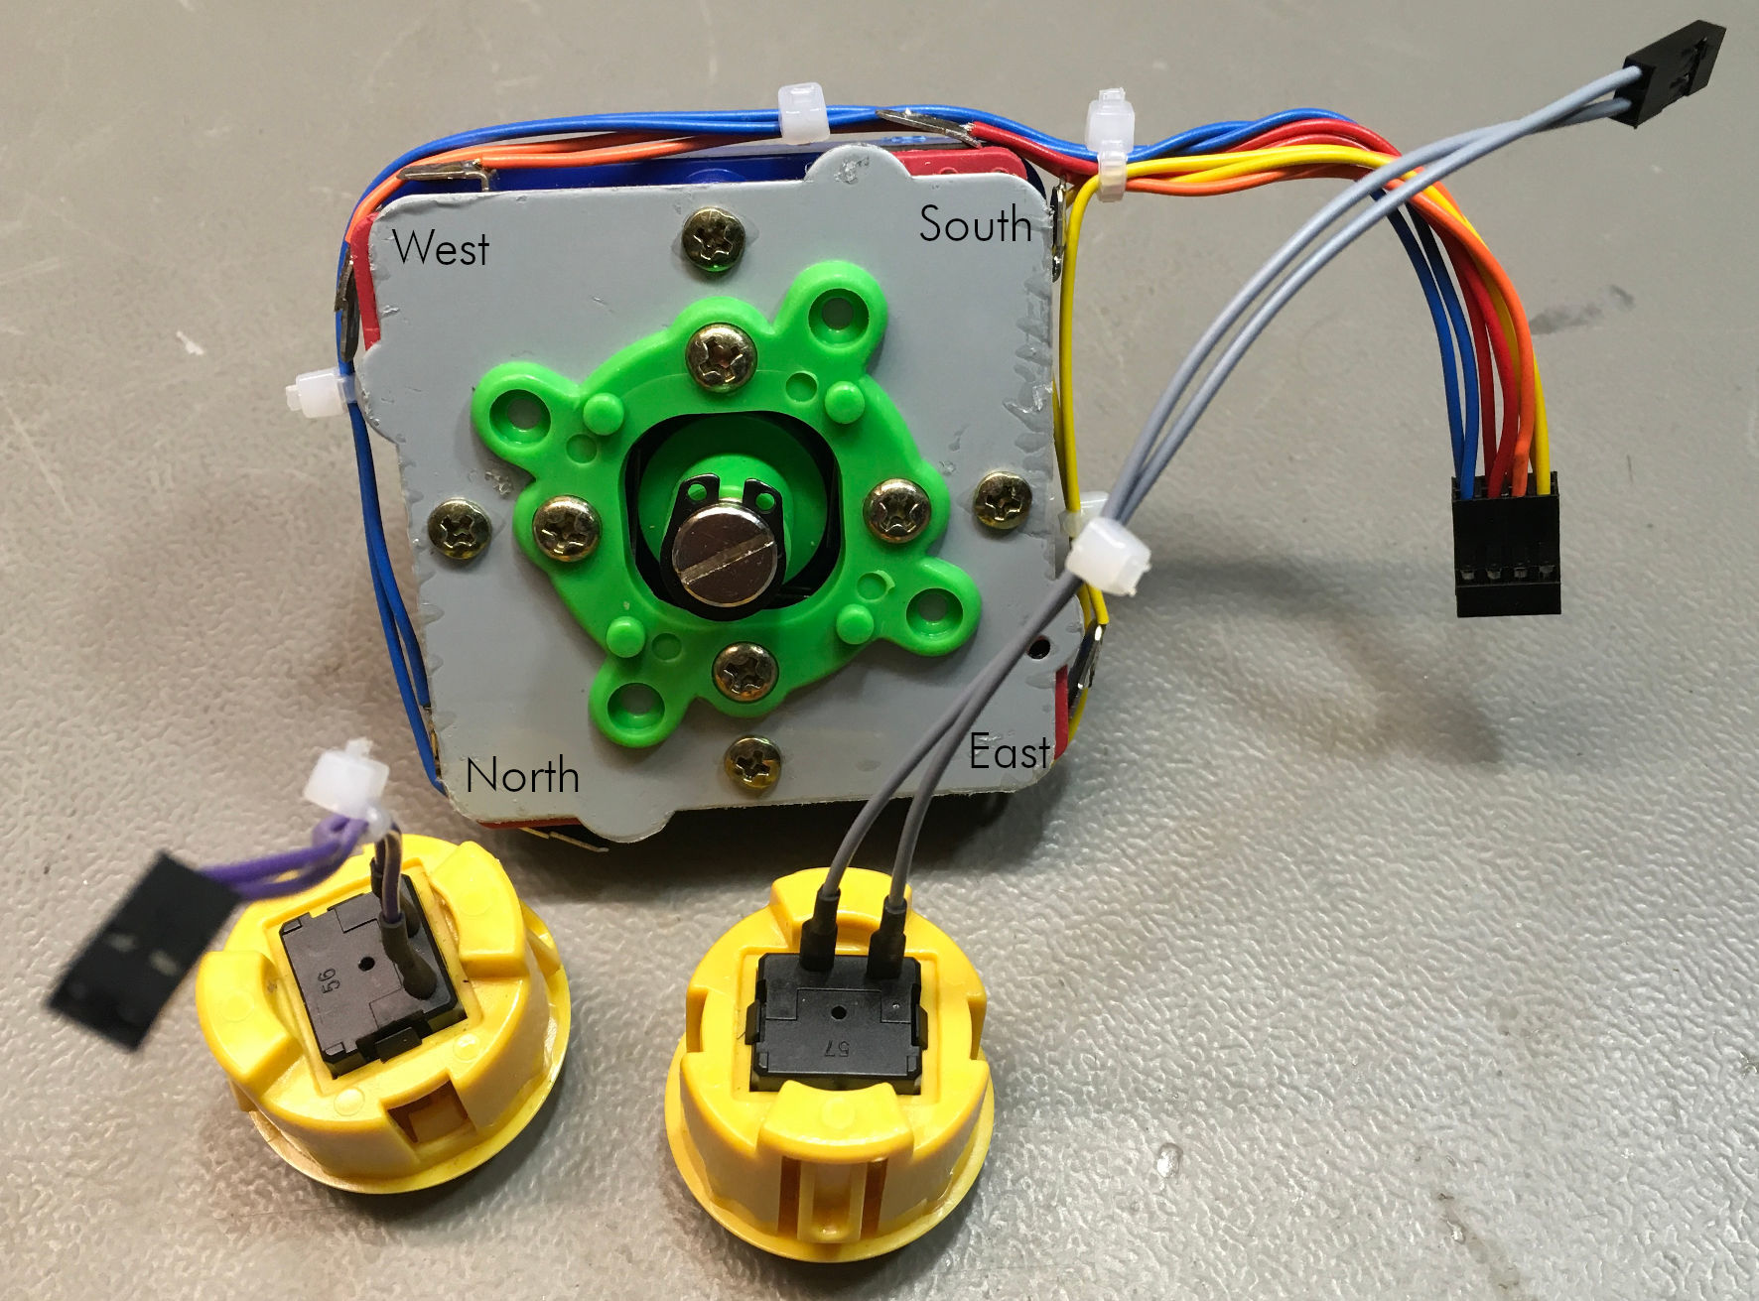

Figure 14: Buttons and joystick with crimp housings

Now, the joystick and the buttons can be mounted into the top shell (Figure 15). The buttons should sit well in the mounting holes. In case they move to much due to a too short snap in pin, they can be secured with a small amount of hot glue. The joystick is screwed to the top shell with countersunk 3.9 x 13mm tapping screws (refer to Figure 4). If the look of the original joystick screws is desired, those can be used. The cover disk and the ball can be reattached now.

Finally, the top assembly can be connected to the bottom assembly. The orientation is shown on the PCB beside the connector for the joystick (J2). It should not be confused. In case of failure, the joystick will behave strange.

The connectors for the buttons have to be oriented from horizontally (see Figure 7, J3). Swapping connection for the left and right button has no effect on the functionality, since both are connected to the same (fire) signal. When connected vertically, the buttons will not have any effect.

A complete and correct wiring is shown in Figure 16.

The joystick can now be closed and screwed with four 2.9x9.5mm screws (see Figure 4). Four rubber feet should be attached to the bottom (Figure 17).

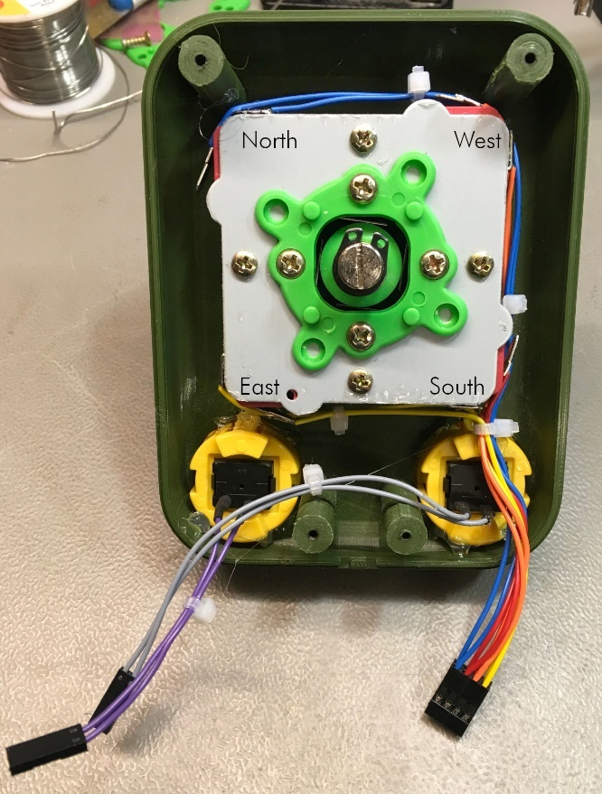

Figure 15: Top assembly

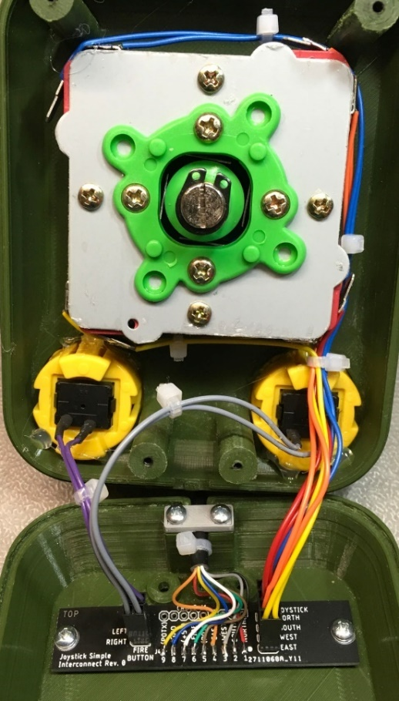

Figure 16: Complete wiring

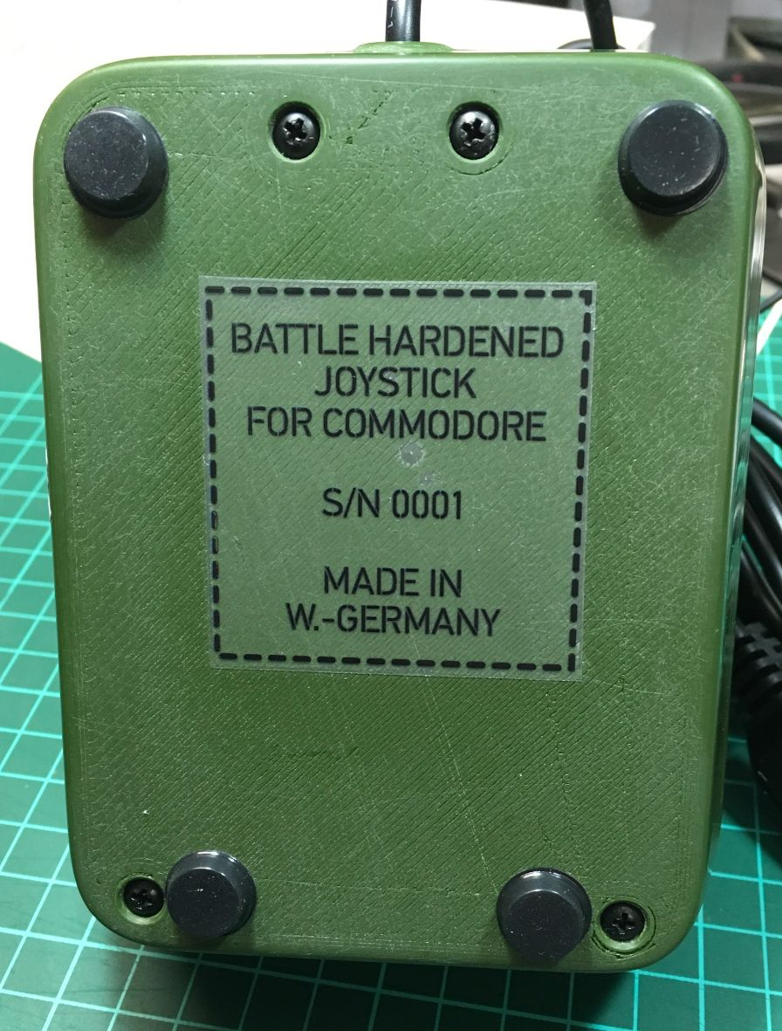

Figure 17: Bottom side of the joystick with rubber feet and serial number

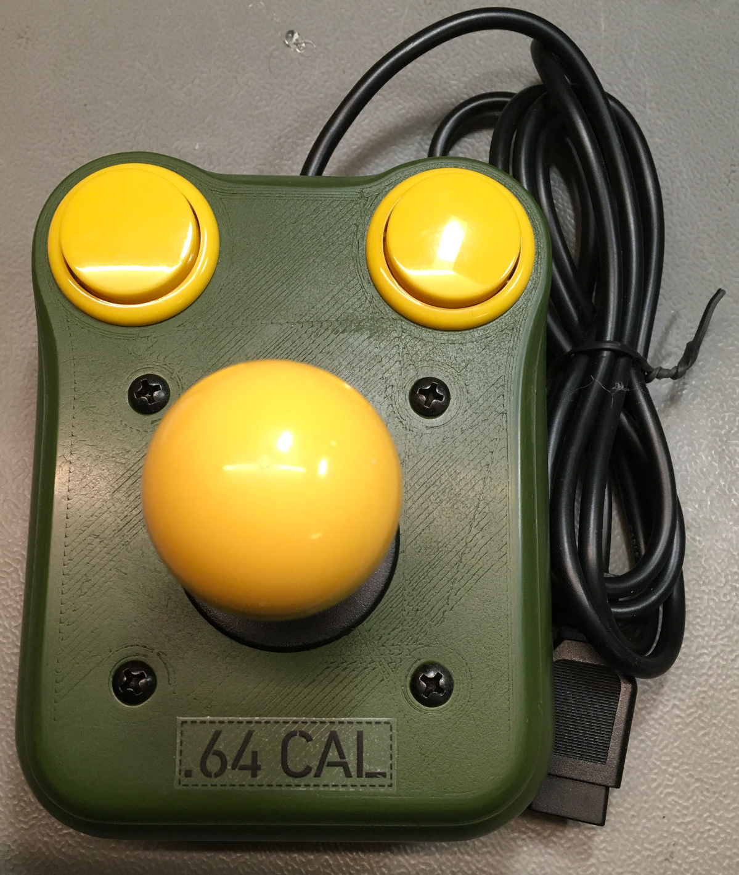

Figure 18: complete joystick (top view)

# Decals

The decals are fun, but not required for the function of the joystick. I have used laser printable, transparent sticker foil (HERMA 4375). Printing other than dark colors on the transparent sticker-foil is not recommended. Light colors require a light background.

The print for the labels can be found in the “inkscape” sub-directory of the “case” directory.

# Simple interconnect PCB

The PCB is very simple (and convenient). Wiring it on a perf board is not a big problem.

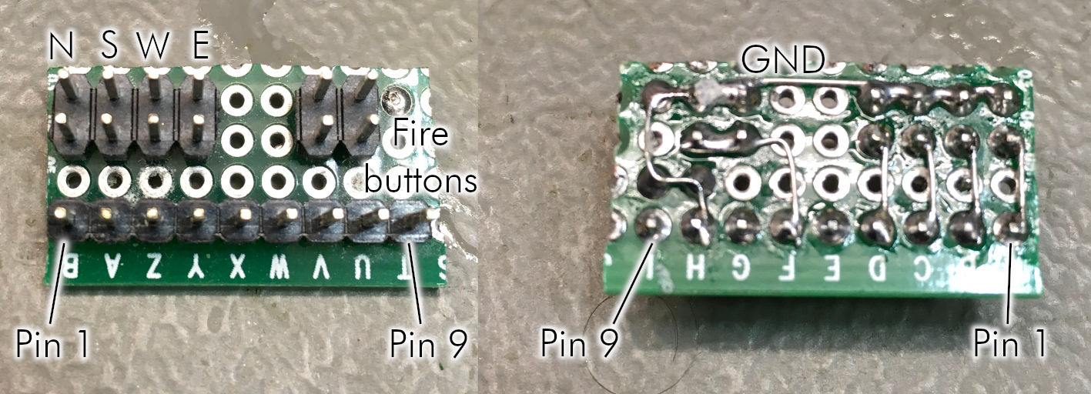

Figure 19: Interconnect on a perf board

The perf board could be attached to the bottom shell with a double-sided tape. A mirror tape is a good solution, that lasts very well.

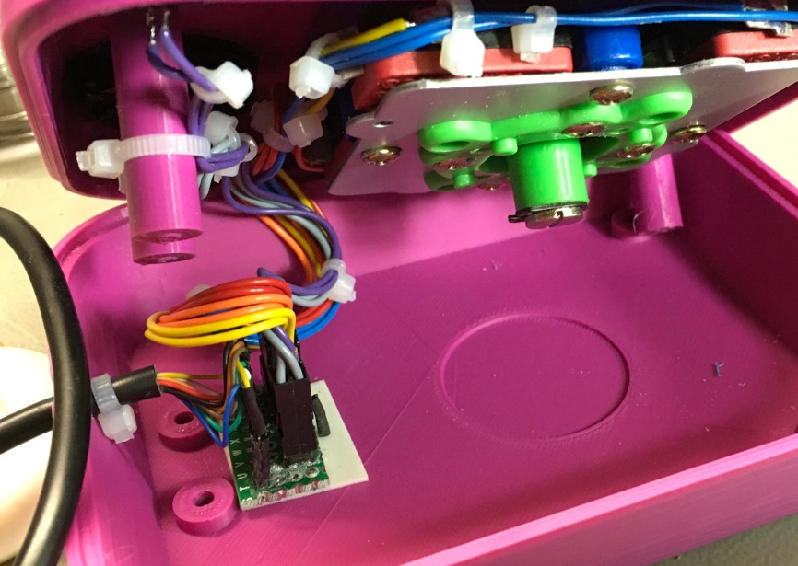

Figure 20: Perf board inside the very first prototype

There are more screw posts inside the bottom shell. These are intended for future developments like an auto-fire board.

# Test

The test can be performed with a joystick test software for the C64, like the “Joytester II” (<https://csdb.dk/release/?id=170175>). Before, it should be made sure (ohmmeter) that the +5V is connected properly. If this would be connected to a button or the joystick, a closed contact would short +5V to ground, which would at least blow a fuse.